**November 2018**

**Volume 5, Issue 1**

Vehicle etiquette



**Overlook marks of respect when boarding or riding a vehicle**



**Don’t**

## Do

### *Let rank determine who boards a vehicle first*

***Let rank determine the position of sitting***

Image retrieved from <https://www.usphs.gov/aboutus/>

### *Let rank determine who exits a vehicle first*

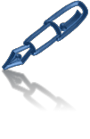

**Bookmark**

#### [USPHS Offi cer ’s Guide: Leadership, Protocol , & Ser vice Standards (2nd ed. )](http://www.coausphs.org/membership/publications/)

* [Uniformed Services Courtesies](https://dcp.psc.gov/ccmis/ccis/documents/CCPM26_1_2.pdf) (Inst 213.01)

**| Leadership | Service | Integrity | Excellence |**

**November 2018**

**Volume 5, Issue 1**

Vehicle etiquette IQ TEST

##### Test your knowledge of Corps’ customs & courtesies.

1. **When boarding a boat with three rear seats—**
   1. Senior rank sits in the right rear, next senior in the left rear, and third senior in the right front
   2. Senior rank sits in the right front, next senior in the right rear, and third senior in the left rear
   3. It doesn't matter as long as senior rank enters and exits first

##### When it comes boarding a vehicle, the rule is .

* 1. Junior rank sit on the left (aft or bow)
  2. Junior rank sit in the back (aft)
  3. Junior rank sit in the front (bow)

##### When entering a vehicle or a boat _.

* 1. Junior rank enters first and exits last
  2. Junior rank enters last and exits last
  3. Junior rank enters last and exits first

## Bookmark

* [The Bluejacket Manual, United States Navy](https://www.usni.org/store/books/professional-books-sea-services/blue-and-gold-professional-series/bluejackets-manual-25t)
* [USCG Regulations](http://govdocs.rutgers.edu/mil/cg/CIM_5000_3B.pdf) (COMDTINST M5000.3)

**Keep your finger on the pulse, check for policy updates at**

<https://dcp.psc.gov/ccmis/bulletin/BULLETIN_archives_m.aspx>

Magnify for answers

##### Policy Awareness and Notification (PAN)

**PDT Mission:** Provide policy guidance and support to the

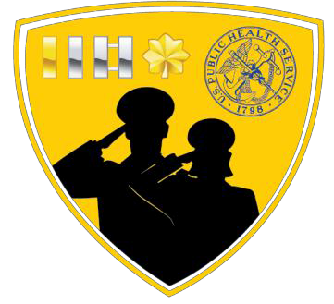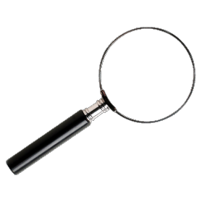

Co-Leads: LCDR Danny Benbassat & LT Rachel Oyewole LCDR Linda Park

LCDR Mindy Chou

LT Stephanie Lanham

LT Maria Agresta Workman

**PAN Mission:** Provide policy guidance and support to the JOAG Policy and Procedures Committee Chair and updates to all junior officers.

The PAN Subcommittee is under the direction of JOAG’s Policy and Procedures Committee (Chair: LCDR Mutiu Okanlawon)